Sean Rettig
2015-05-07
ROB 421
Group 1

Individual Lab Report 2

So far, I have contributed primarily to the computer vision, remote control, and computer-microcontroller communication aspects of our robot, whilst also maintaining the project website and providing general support to the rest of the team as we designed, built, and tested our robot.

In the last individual lab report, I mentioned working with Martin to develop a protocol for communication between the microcontroller and computer. As of now, both sides of this protocol are currently working and the robot can be controlled entirely from the computer. The user can select a cup to shoot for by drawing a box around it with their mouse on a webcam feed window, and the robot will use feature tracking to center itself on that cup by moving the carriage left or right until the cup is in the middle of the webcam view (the webcam is mounted above the barrel of the launcher). To control the distance of the shot, the user selects whether the cup is in the first, second, or third row; the launch motor speed is adjusted automatically to optimal values determined by testing. In the event that manual tweaking is required (such as in the event of a headwind), the user also has manual control of the launch motor speed slider. Once the speed is set and the carriage is in position, the computer sends a “shoot” command to the microcontroller, which then loads the next ball and shoots.

This simple approach should increase the robustness of cup aiming because a) it allows us to take advantage of the known distances to the cups rather than trying to detect them using vision, and b) since cups are no longer tracked using ellipse detection but rather by feature tracking, cups can be tracked more reliably in different lighting conditions. For example, the previous system was not able to detect cups that were partially shadowed very easily since the cup openings no longer appeared as single ellipses, but rather as two halves of an ellipse. The feature tracking system mitigates this because if a partially shadowed cup is selected, that selection in its entirety is tracked as normal, shadows and all. In the event of moving shadows and the like, the system is still able to track cups throughout minor variations in lighting, but major variations do cause failure. However, the cup can be reselected if the target is lost, and as a last resort, the carriage could still be manually controlled; the tracking system is primarily used to speed up the aiming process over entirely manual aiming and is not absolutely critical to the function of the robot (just very helpful).

Additionally, the old vision system had issues with detecting cups that were extremely close together (as they would be in beer pong) because the white ellipses of their openings were detected as one contiguous, non-ellipse shape. The new system mitigates this as well since we are no longer tracking ellipses, but arbitrary features. There are still some minor glitches to work out, but in general, the new tracking system works quite well.

The original ellipse detection code used for cups has been repurposed for detecting bouncing ping pong balls, as ping pong balls are still white ellipses and can't be tracked using the same arbitrary feature tracking method as cups since we won't have enough time to select them. Further work is still required to fix the detection in inconsistent lighting conditions, but this has not been a priority as our swatting arm has yet to be implemented anyway.

These three main areas of computer vision, remote control, and computer-microcontroller communication make up the core of the computer's responsibilities and are ultimately responsible for how the robot functions on a high level; computer vision failure will lead to slow and/or inaccurate shots and missed swatting opportunities, remote control failure may prevent us from even trying to shoot at all, and computer-microcontroller communication failure can lead to the robot being inaccurate, locking up, or even destroying itself.

My plans for the next week include putting the finishing touches on the shot selection GUI, working on its networked functionality, and tweaking the cup tracking to be a bit more reliable. I also plan to work on the bouncing ping pong ball detection further so that we can be ready to test our swatter once it has been implemented in the mechanical and electrical sides. Eventually, I also plan to perform some test shots to correlate motor speeds with shot distances for automatically setting the correct motor speeds, but as our launching mechanism is still being tweaked to improve accuracy, I must wait for the design to be fully finalized.

Picture of current robot and launching/reloading mechanisms (not mounted on carriage):
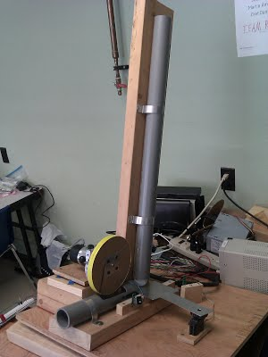
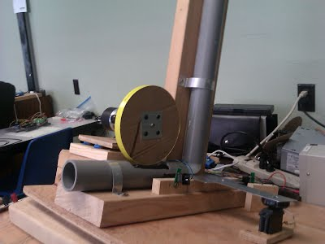

Recent test of ball landing locations from launcher (it has since been modified):
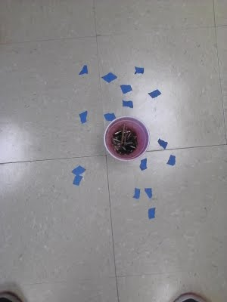

Microcontroller/motor controller board:
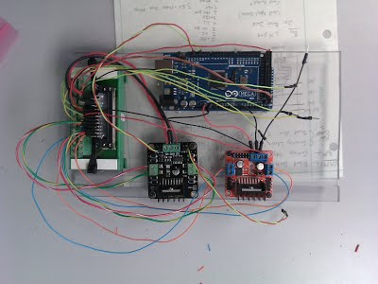

Screenshot showing selection and tracking of a cup:
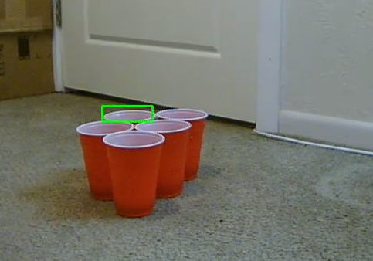
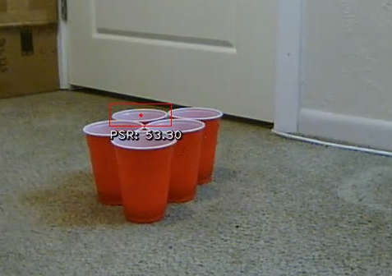

(video at https://www.youtube.com/watch?v=XwIh_asY1-0)

Screenshot showing shot selection GUI:
